CTM-I Use Case

Dynamic Parm Edit Linked

Version 0.1

Use Case Name | Dynamic Parm Edit Linked
Actor | App Support
Pre-conditions /Assumptions | User has selected a specific Parm to edit. The parm is related to a specific Parm Definition. The Parm Definition is a linked definition.
Post Conditions | User can choose to return to the previous browse screen by selecting the “Return to Browse” link. The link will take the user back to the browse screen they came from. The user’s latest search criteria and sorting will be used to display search results.
Screenshot | 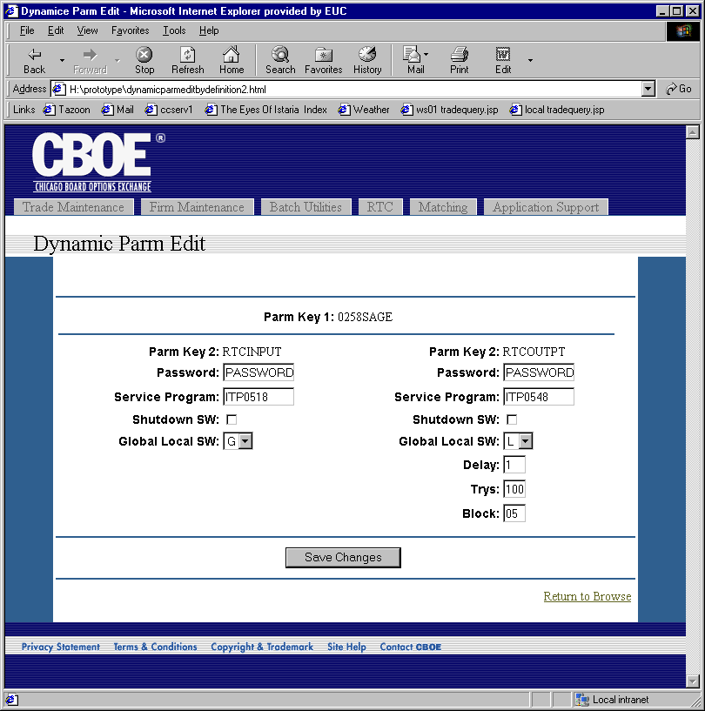
Flow of Events | - Parm Key 1 and Parm Key 2 are used to get the Parm from CTM-R.  - Parm Key 1 and Parm Key 2 are used to get the proper Parm Definition for the Parm.  - Using the Parm Key 1 and the Parm Definition Linked Key 2, the linked Parm is retrieved from CTM-R.  - The linked Parm Key 1 and Parm Key 2 are used to get the Parm Definition from CTM-R.  - Dynamic Parm Edit Linked screen displays.  - Parm Key 1 and Parm Key 2 are read-only fields.  - The screen will display with the two linked Parms side by side. Each will use their own Parm Definition to dynamically define the fields displayed.  - The Parm Definition will determine editable fields. The Parm Definition type will be used to determine the type of input field and what validation to perform.  - Pressing the “Save Changes” button will save the changes  - Changes will be reformatted to the proper form based on the Parm Definition.  - The parms will be passed to CTM-R to save.  - Results from CTM-R will be displayed.
Alternative Path | If the Parm Key 1 and Parm Key 2 do not match the requirements of the specified Parm Definition, the user will be redirected to the Generic Parm Edit Use Case

